

CV

Marlon Vernon Bernardes

Sales & Marketing
AI Lead Gen & Automation Business Development Project Management Design & Creative

Online CV/ Portfolio:
www.mvsite.co.za/portfolio

Introduction

A results-driven professional with over 15 years in digital marketing and sales, I bring a demonstrated ability to spearhead growth initiatives and optimise operational efficiency. My expertise encompasses AI-driven lead generation & Automation, business development, and project management, all underpinned by a strong foundation in data analytics and creative execution. My passion lies in fostering cross-functional collaboration and leading teams to excel in dynamic, growth-oriented environments. I welcome the opportunity to discuss how my proven capabilities can accelerate your company’s success.

Kind Regards.

Marlon Vernon Bernardes



Leadership & Business Acumen
- Certificate : Basic Accounting
- Diploma: Leadership Skills in Business

Digital Marketing & Sales
- Diploma: Google Ads
- Diploma: Digital Marketing
- Diploma: Sales Management
- Diploma: Integrated Marketing
Management
- Google Certification: Google Digital Sales
- Google Certification: Google Ads
Fundamentals
- Google Certification: Google Ads Display
- Google Certification: Active Customer
Centric Marketing
- Certificate: Strategic Planning & Market
Research
Artificial Intelligence & Automation
- Certificate: Artificial Intelligence
Masterclass
- Certificate: Artificial Intelligence & Lead
Gen Automation

Business Development & Project Management
- Certificate: Business Development
- Certificate: Data for Business Intelligence
- Diploma: Project Management

Design & Creative
- National Diploma: Graphic Design
- Photography N6
- Certificate: Web Design
- Certificate: Adobe Indesign Advanced
- Certificate: Adobe After Effects, Premiere
Pro
- Certificate: Vinyl Cutter, Ghost,
Sublimation Training

Artificial Intelligence & Automation
  - Certificate: Artificial Intelligence Masterclass (2020-2022, Alison - Online)
  - Certificate: Artificial Intelligence & Lead Gen Automation (2020-2022, Alison - Online)

Business Development & Project Management
  - Certificate: Business Development (2025,
Alison - Online)
  - Certificate: Data for Business Intelligence

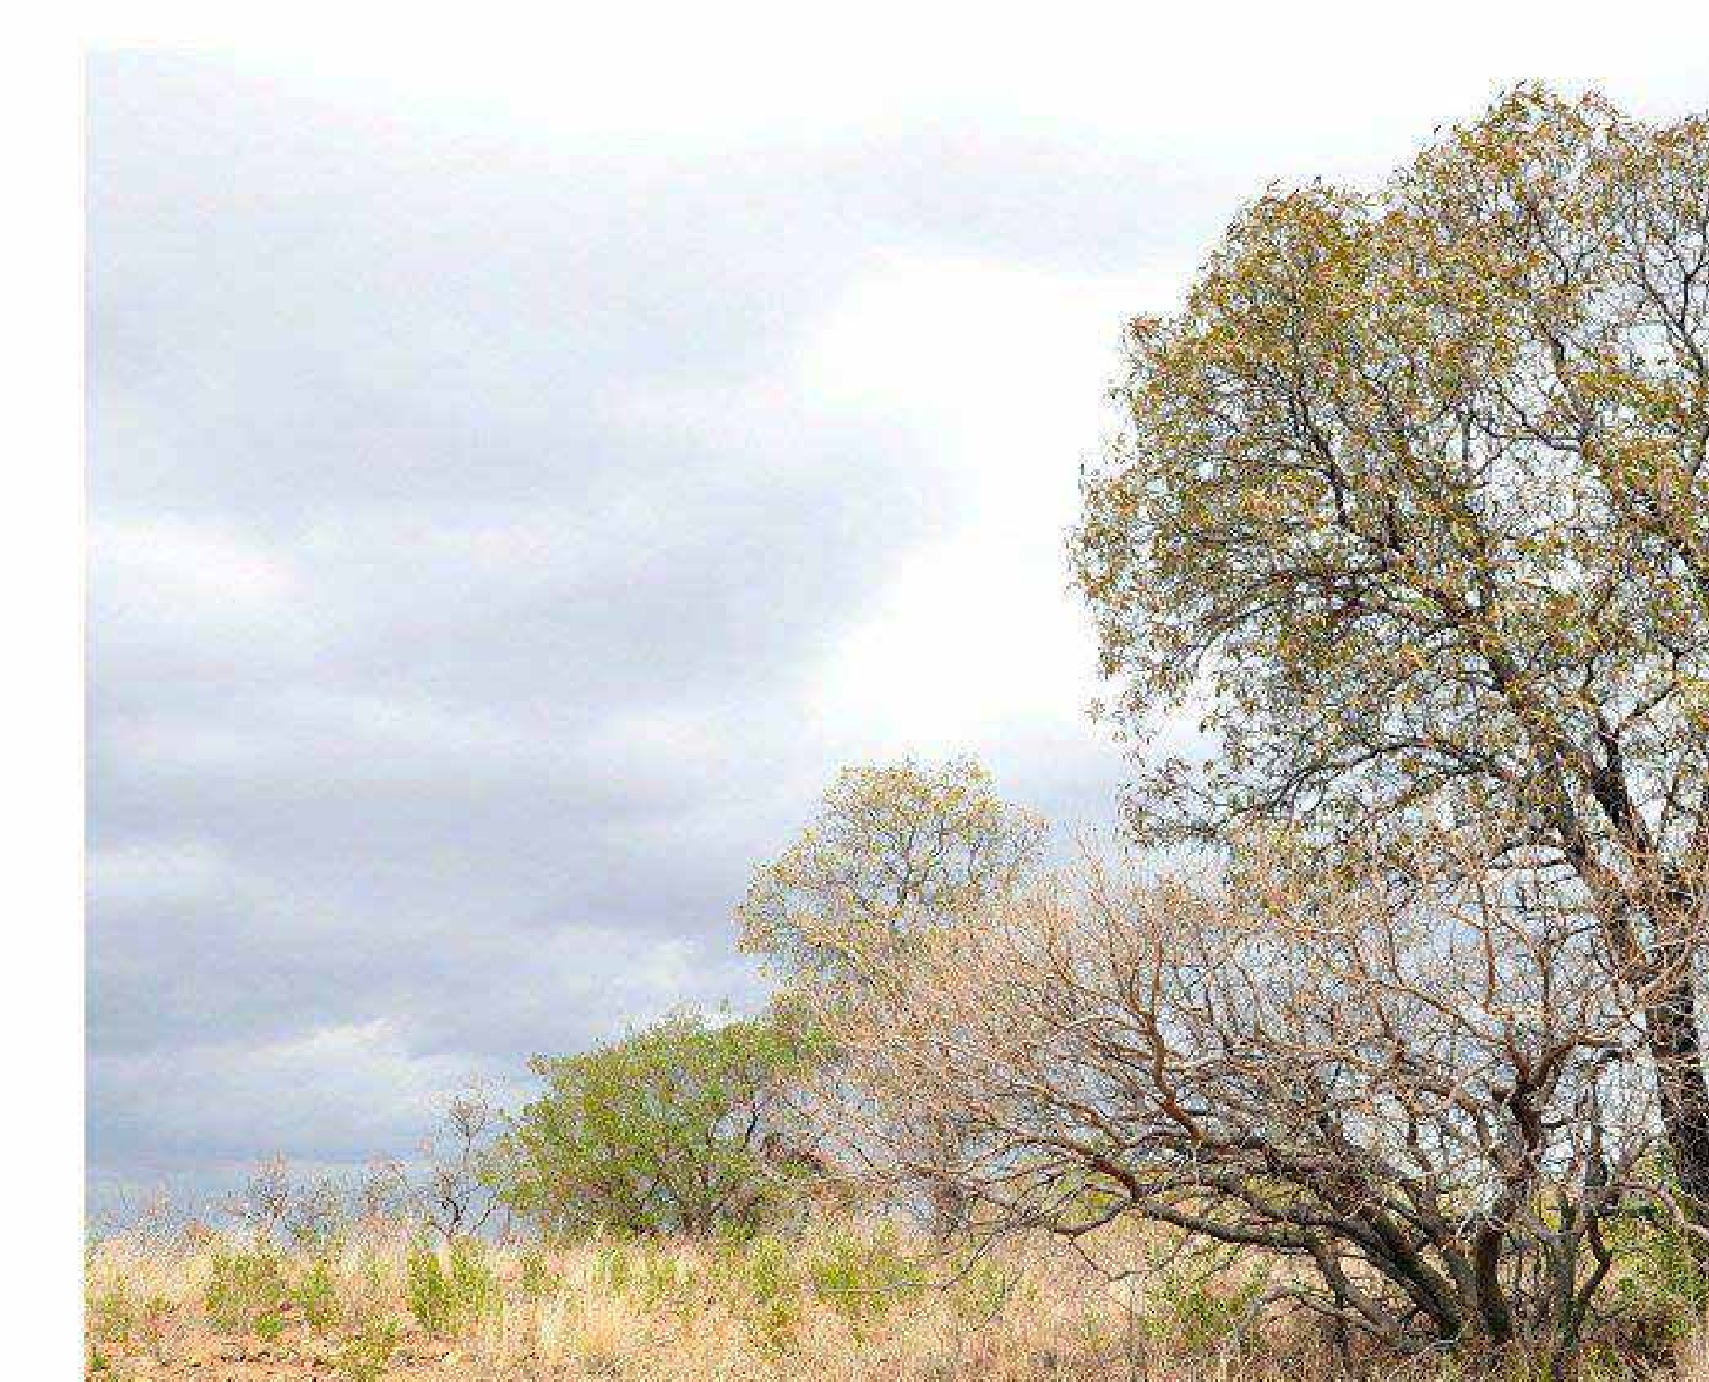

Qualifications

Strategic Leadership & Business Acumen
- Certificate: Basic Accounting (2025, Alison
- Online)
- Diploma: Leadership Skills in Business (2019-2022, Alison - Online)

Digital Marketing & Sales
- Diploma: Google Ads (2025, Google -
Online)
- Diploma: Digital Marketing (2018, Shaw
Academy - Online)
- Diploma: Sales Management (2019-2022,
Alison - Online)
- Diploma: Integrated Marketing Management (2019-2022, Alison - Online)
- Certificate: Google Digital Sales (2018- 2019, Google - Online)
- Certificate: Google Ads Fundamentals (2018-2019, Google - Online)
- Certificate: Google Ads Display (2018- 2019, Google - Online)
- Certificate: Active Customer Centric Marketing (2018-2019, Google - Online)
- Certificate: Strategic Planning & Market Research (2025, Alison - Online)
(2025, Alison - Online)
- Diploma: Project Management (2019-2022,
Alison - Online)

Design & Creative
- National Diploma: Graphic Design (2003- 2004, Ekurhuleni East Campus)
- Subjects: Drawing, History of Art, Graphic Processes, Graphic Design (Distinction)
- Certificate: Photography N6 (2006, Ekurhuleni East Campus)
- Result: Distinction received
- Certificate: Web Design (2007-2009,
Alphaweb)
- Certificate: Adobe Indesign Advanced (2007-2009, Desklink Media Solutions)
- Certificate: Adobe After Effects, Premiere Pro (2010s, Lab Space)
- Certificate: Vinyl Cutter, Ghost, Sublimation Training (2010s-Present, JG Electronics)

Other Training
- Qualification: Matric (National Senior Certificate) (2002, Hoërskool Oosterlig)
- Subjects: Afrikaans, English, Accounting, Business Economics, Mercantile Law, Technical Drawing
- Certificate: Fire Fighter Training Level 1 (2011-2017, IEFA)

Skills / Experience

Digital Strategy, Business Growth & Operations
A results-driven professional with over 15 years’ experience in digital marketing, sales, and creative production, excelling in strategic planning, AI integration, data intelligence, and business development
to drive growth and optimise operations.

  - Leadership & Operations: Proven 2iC experience in leadership, managing teams, projects, and workflow; skilled in process improvement, efficiency, financial
oversight, and stakeholder communication.

  - Digital Marketing & Sales: Expert in Google Ads, Analytics, SEO, and social media campaigns (Facebook, Instagram, LinkedIn, TikTok); drives lead generation, builds sales funnels, and has a track record of achieving significant engagement and sales increases (e.g., +35% engagement, +20% sales on AR Christmas campaign).
- AI & Automation: Certified in AI Masterclass & AI in Lead Generation, leveraging AI for content generation, campaign automation, and enhancing sales processes.


Business Development & Project Management:
Strong B2B/B2C background, developing sales funnels and managing CRM; proficient in Project Management for timely, successful initiative delivery.

- Design & Creative: Advanced in Adobe Creative Suite, CorelDRAW, Premiere Pro, and After Effects; proficient
in web design (WordPress, Joomla, Prestashop), DTP, branding, and prepress.

- Professional Photography: Over 25 years of successful professional photography, including over 300 weddings (some featured), magazine covers, and product shots.

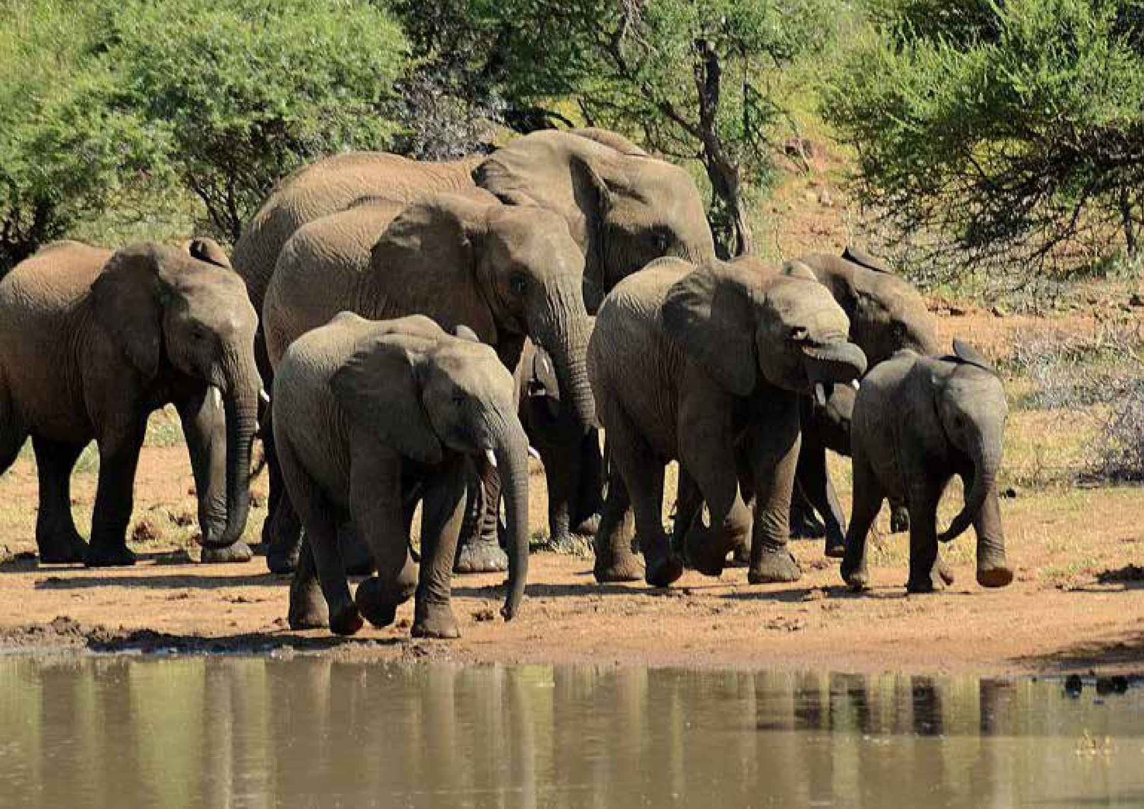
Employment History | References

  - AJP Advance | 2iC Team Lead | Graphic Designer April 2023 – April 2025
Reference: Theo Singo, Key Accounts Manager, 060 500 4372
  - Hakunamatata Venue | Freelance Digital Marketer / Designer
September 2019 – February 2024
Reference: ML De Villiers, Sales, 072 048 0578
  - GetPix Creative College | Freelance Instructor (Various Modules) February 2020 – February 2021
Reference: Paula Rutherford, Principal, 072 110 2873
  - Bulldog Abrasives | Graphic Designer, Photographer, Video Editor, Marketing Support, July 2018 – November 2018
Reference: HR Department, 011 786 5991
  - Regal Security | Graphic Designer, Photographer, Video Editor,
Marketing Support
April 2010 – June 2018
Reference: HR Department, 011 553 3300
  - Print 2000 | Senior Graphic Designer
November 2008 – March 2010
Reference: Adri Cooley, Founder / Owner, 011 893 3255
  - Caxton CTP | Middle Weight Graphic Designer June 2007 – October 2008
Reference: Amanda Thanasaras,
Former Production Manager, 074 892 4261
  - Geo Constable Printers | Junior Graphic Designer December 2004 – May 2006
Reference: Elize Bezuidenhout,
Former Senior Graphic Designer, 083 308 1199
  - TC Enterprises | Part Time Service Technician
January 2000 – December 2004
Reference: Marcell Bernardes, Former Employee, 074 661 5668
  - MV Photography | Self-Employment / Freelance Projects Since 2000 ~ www.mvphotography.co.za
Encompasses professional photography (including over 300 featured weddings, magazine covers, and product shoots), graphic design, web design, social media management, and Google Ads campaigns. This business has since been handed over to my fiancé to manage fully.

AJP Advance

Team Lead (2iC)
(October 2024 – April 2025)

Graphic Designer
(April 2023 – October 2024)

At AJP Advance, I initially focused on designing marketing materials, advertisements, and digital content,
ensuring quality and consistency. While
graphic design was my primary role, I took on additional responsibilities,
including project coordination, workflow improvements, and problem-solving. My contributions extended beyond design, actively enhancing internal processes and supporting business strategies.

Promotion to Team Leader (2iC) (October 2024 - Current)

Expanded Role & Responsibilities In September 2024, I was promoted to Team Leader (2iC). My role expanded significantly, requiring me to manage operations, oversee the team, and
ensure the company meets its business
objectives efficiently.

Leadership & Team Management:
Directly oversee team operations,
ensuring all members are aligned with company goals, meeting deadlines, and maintaining high performance.
Strategic Problem-Solving: Proactively resolve daily challenges, implement structured solutions, and enhance team productivity.

Financial Oversight & Costing Accuracy: Improving accuracy in quotations and invoicing, leading to better financial tracking.

Operations & Process Improvement: Optimised internal workflows, increasing productivity and reducing inefficiencies. Developed structured processes for task allocation, reporting, and accountability to ensure smooth day-to-day operations. Handle daily problem-solving, address operational challenges, and proactively implement solutions to prevent recurring issues. Standardised procedures
to improve team collaboration,
communication, and overall efficiency.

Project Management
Oversee project lifecycles, ensuring tasks are completed on schedule and exceed client expectations. Coordinate with stakeholders, manage resources
effectively, and adapt to evolving project needs. Implemented a structured task- tracking and reporting system to enhance visibility, accountability, and deadline management.

Key Achievement: Online Campaign for AJP Group Pick ‘n Pay:
Led the campaign strategy, focusing on engagement and customer retention.
Developed effective stakeholder communication, ensuring smooth execution and alignment with business objectives. Optimized performance metrics, resulting in increased traffic and participation. Oversaw prize distribution and campaign logistics, improving customer satisfaction and brand loyalty.

Skills & Expertise:
- Leadership & Team Management
- Operations & Workflow Optimization Business Strategy & Process Implementation
- Financial Oversight & Costing Accuracy
- Stakeholder & Director Communication
- Project & Task Management

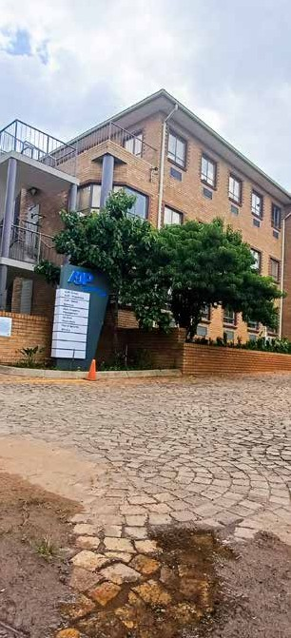



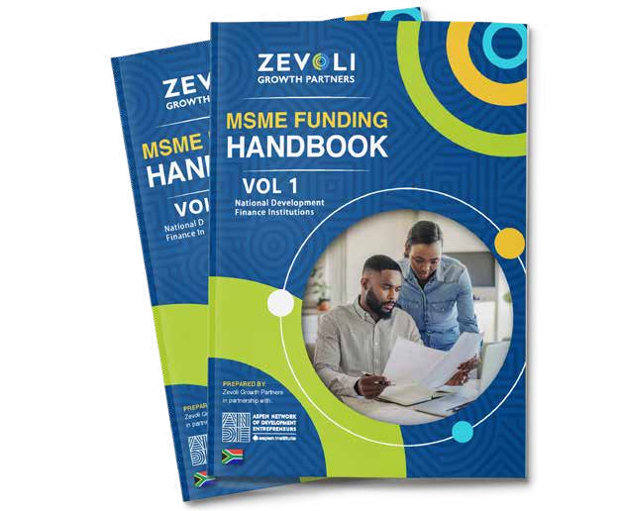
Zevoli Growth Partners

As part of the internal Brand Connect team, I played a crucial role in shaping and enhancing the creative visual identities of Zevoli and Linkage. I offered creative support and graphic design expertise for various digital assets and branded materials, spanning websites, newsletters, magazines, and advertisements.

Working closely with the internal team and stakeholders, I ensured the timely delivery of marketing communications aligned with brand guidelines. I crafted collateral for diverse routes to market, including web, mail, digital, and print.

I meticulously maintained and developed brand identity and visual guidelines, ensuring adherence across
all creative materials. Additionally, at Zevoli Growth Partners, I contributed to MSME projects, adapting to varied organizational needs and achieving significant cost savings.


Hakunamatata Venue - Freelance Digital Marketer & Designer

In my role as Digital Marketer and Designer for Hakunamatata Venue, I played a pivotal role in shaping the company’s growth trajectory. My responsibilities encompassed the comprehensive management of corporate marketing and design, with a primary focus on building the brand and establishing a robust online presence.

I crafted and executed successful marketing strategies that were closely aligned with organizational objectives, including national campaigns aimed at expanding the reach of the brand. My decision-making was informed by
meticulous competitor analysis and continuous monitoring of market trends, ensuring business development efforts were both strategic and effective.
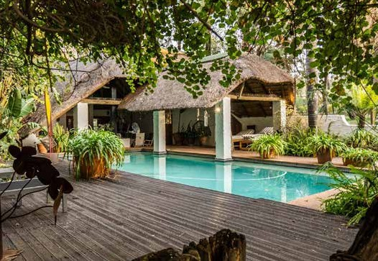
I ensured that the brand maintained a visually appealing presence across various platforms. Through collaborative efforts with external partners, I capitalized on strategic marketing opportunities to further enhance our brand visibility. Additionally, Collaborating seamlessly with cross- functional teams, developing impactful sales and collateral content, strategically engaging in Digital Marketing and communication.



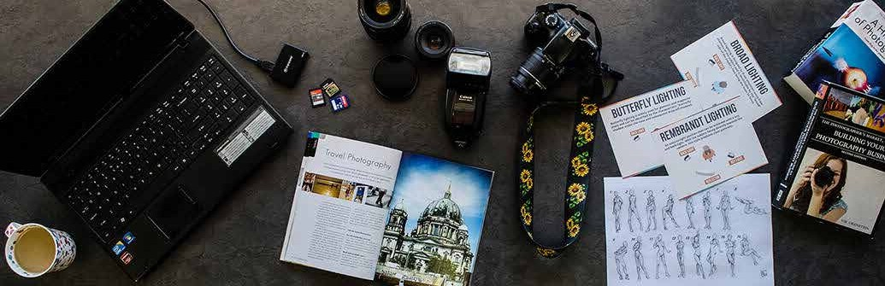
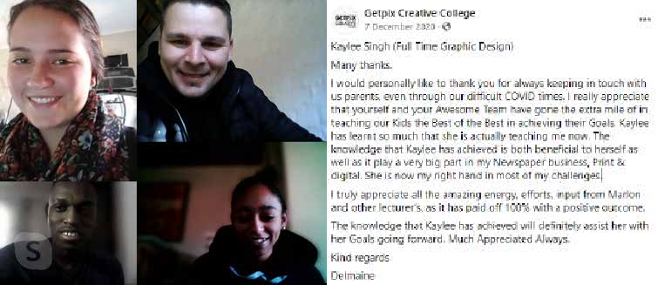
GetPix Creative College

As a Get Pix Lecturer, I provided training in Design, Photography, and Social Media Marketing. Ensured effective teaching by thorough preparation and adherence to lesson plans. Monitored student attendance and commenced lessons punctually. Engaged
students through clear presentations and effective time management. Maintained supportiveness and promptly addressed individual needs. Assessed and marked tests, providing constructive feedback. Submitted test results promptly for administrative processes.

To whom it may concern,

This confirms that Marlon was one of our Graphic design instructors during 2020. He taught Adobe software to our students. He is a firm, dedicated instructor with the students’ best interests at heart. He was well liked by our students. He was always timeous and was at work every day required to teach.

Sadly our company is closing this year. I can be contacted on 072 110 2873 Paula Rutherford
Principal

REGAL Security

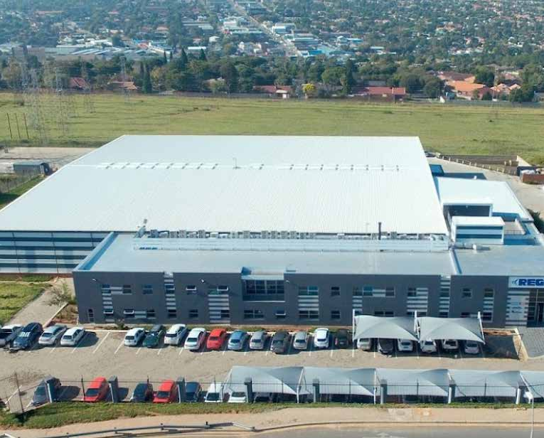
Position: Graphic Design & Marketing Coordinator

Collaborated with managers and directors to oversee creation of advertising and marketing materials. Contributed marketing ideas, concepts, and design to meet project briefs.
Assisted in developing and launching marketing campaigns, coordinating production services. Managed design department projects, ensuring seamless coordination. Acted as point person during Marketing Manager’s absence. Planned, executed, and edited video content for branches, optimizing post- production. Created video content
for various platforms, staying current with industry trends. Designed a wide range of projects, including marketing materials and digital content. Managed promotions and email marketing,
occasionally designing creative concepts. Developed branding for exhibitions and displays, assisting in event management. Supported general marketing and administrative duties.

*Similar duties at Bulldog Abrasives



TC Enterprises Geo Constable Printers Caxton CTP Print 2000

Installed Tachographs, Engine Protection, and Fleet Management systems with precision. Maintained meticulous
records, ensuring accurate completion of technicians’ job cards. Provided hands-on assistance during breakdowns and field service operations, optimizing problem-solving. Managed daily routes for efficiency and resource allocation.
Maintained detailed time sheets to promote productivity. Conducted monthly stock takes for accurate inventory management. Offered expert technical support to clients, ensuring satisfaction. Managed fleet vehicles through regular inspections and maintenance. Efficiently handled budget for fuel levy and operational costs. Assisted with accounts management using QuickBooks.
Oversaw ordering of promotional items to enhance brand visibility. Implemented new job cards to improve field service efficiency.

Position: DTP / Graphic Designer Reporting Structure: Directly reported to Senior Designer
Collaborated with Senior Designer to create precise, visually appealing
designs. Interacted with clients to fulfill design requirements effectively. Managed entire design process from concept to production. Followed prepress protocols for print preparation. Maintained
high standards in color separations and registration. Conducted rigorous quality control checks for flawless artwork. Ensured project continuity in absence of Senior Designer. Installed
software updates for peak performance. Implemented backup system for data security. Managed procurement of essential supplies. Provided assistance to other departments as needed.

Position: DTP / Graphic Designer
At GetIT Magazine, I contributed to monthly magazine layout and design, ensuring adherence to corporate identity guidelines and strict deadlines.
Responsibilities included placing advertisements for visual coherence and designing impactful full-page and double- page spread features. Additionally,
I played a key role in photography, capturing magazine cover shots, product/ event photography, and portraits.
I also designed adverts and features for nine newspapers, showcasing versatility. Within the design team, I mentored junior designers and acted as Creative Director in their absence, ensuring project continuity and quality.

Position: DTP / Senior Designer
Demonstrated precision and attention to detail while working independently on design projects. Communicated effectively with clients to understand
their design needs, ensuring satisfaction.
Managed the entire design process from concept to production, adhering to Corporate Identity (CI) guidelines.
Implemented prepress protocols for print-ready artwork. Conducted rigorous quality control checks to uphold
high standards. Proficiently handled quotes and invoices for streamlined financial processes. Submitted quotes and invoices promptly and organised outstanding payments. Managed software updates and upgrades. Expertly handled procurement of essential supplies and resources.

Key Achievements


A digital marketing professional with a unique background spanning print and graphic design, adept at
managing both creative and technical aspects of campaigns. I leverage
my extensive experience in content creation, SEO, social & digital marketing, and campaign strategy to drive significant growth across hospitality, retail, and e-commerce.
- Strategic Campaign Development
& Execution:
- Expert in Google Ads, Facebook Ads, Google Analytics, SEO, and CRM.
- Proven track record in end-to-end campaign management, from strategy and planning to content creation, social media, and full execution.
- Skilled in market research, competitive analysis, and developing strategies for new product promotion.

Key Campaign Achievements
- PnP Christmas Games Digital Campaign: Drove R400,000+ in sales from over 2,000 participants (800 completed entries) via a gamified WordPress site.
- Hakunamatata Venue Digital Strategy: Achieved a 65.5% increase in website users and 67.6% growth in active user engagement through optimized Performance Max campaigns on Google/Facebook Ads and SEO efforts (resulting in 2.9K organic search sessions), maintaining ad spend below ZAR 200 per campaign.
- Christmas AR Hunt – AJP Malls: Generated R150,000+ in sales and boosted foot traffic with over 2,000 participants and 300 completed entries.

- GoZone #GoLike Marketing Campaign: Achieved 453 organic entries with zero ad spend, significantly increasing brand engagement.

Digital Leadership
Successfully implemented digital marketing strategies during challenging periods (e.g., Covid lockdown for Hakunamatata), resulting in increased sales and lead generation.

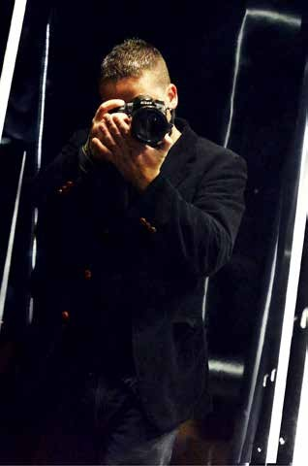
Self-Employment / Freelance Work

Family Influence and Career Journey

My entrepreneurial spirit comes from my father, Antonio De Oliveira Bernardes, who brought his Portuguese heritage and business skills to South Africa. Though he passed away early, he inspired my passion for entrepreneurship.

With my family’s support, I pursued photography and earned a distinction in my course. Despite challenges, I stayed dedicated, gaining recognition and establishing MV Photography. I have been a professional wedding photographer for over 15 years, developing strong business strategy, marketing, and sales skills.

My journey shows how family influence and determination can drive success in following one’s passion.

MV Photography: Since 2000
www.mvphotography.co.za

Frequently Asked Questions

Am I currently employed?
No

Dependants?
2

Last Salary Earned?
R41 000 per month, with Petrol Allowance & Provident Fund benefits.

Looking For?
R46 000 - R56 000 per month

Notice Period?
Available Immediatly

Where do I currently reside?
Hakunamatata Venue in Muldersdrift

Would I mind an ITC background check? Welcome to check my ITC, considering financial circumstances during COVID.

What skillset would I prefer doing the most?
Balanced mix of analytical and creative abilities.

How would I handle conflict / issues in the workplace? Adhere to company policies and procedures, aiming to resolve issues through direct communication.

Where do I see myself in 5 years?
Becoming a leading industry professional, respected and known.

Good Health?
No medical conditions.

Any criminal Records?
None

Strengths?
Leadership, problem-solving, team orientation, multitasking, strategic planning.

Weakness?
I actively manage perfectionism by prioritizing efficient delivery, and continuously refine my direct communication style for enhanced diplomacy.

Would my Wedding Photography become a conflict
of interest?
No conflict of interest, limited bookings on weekends and managed separately from professional roles.

Task/Test Requests: Due to significant experience and comprehensive documentation available (including references and portfolio), I will not be completing unremunerated tasks or tests as part of the recruitment process. My time is valuable, and prioritized for productive engagements and continuous personal development.



20 February 2023

To whom it may concern:

To Whom It May Concern,
10 June 2024

1st Floor Elgin Mall Birchleigh 1625
PO Box 7560 Birchleigh Kempton Park 1621
LETTER OF RECOMMENDATION: MARLON BERNARDES

Marlon Vernon Bernardes worked at Zevoli Growth Partners as our Graphic Designer from 1 July 2022

I am writing to highly recommend Marlon Bernardes, who has been an invaluable member of our team at AJP Advance. Employed as a Graphic Designer and Desktop Publisher, Marlon has consistently demonstrated a remarkable range of skills that extend far beyond his designated role.

Marlon exhibits exceptional initiative, often taking it upon himself to build and enhance projects independently. His proactive approach and innovative mindset
have contributed significantly to various aspects of our business. Marlon is not just a
e. info@ajpg.net
w. www.ajpg.net
t. +27 11 390 4300

AJP Group Technologies (Pty) Ltd 2016/036950/07
Directors
J. Philippou
D. loannou
until 28 February 2023. Unfortunately, due to restructuring of the business and operational requirements, his position was retrenched.

We can recommend Marlon as an innovative Graphic Designer with e-Commerce Website Design skills. He solely designed our SharedImpact platformed, which we initially wanted to outsource, resulting in a saving of R100 000 for us. Marlon demonstrated the ability to be creative and worked well within our team. He also showed himself to be a fast learner, which meant he could adapt to changes quickly without compromising quality standards.
Marlon was always willing to offer his assistance and have an excellent rapport with our clients, employees and service providers. He would add value to any company, and I recommend him for any

team player, he is a driving force behind many of our creative and operational successes.

His contributions include, but are not limited to, generating original ideas, refining processes, and adding substantial value across multiple areas of the company.

Marlon's versatility and dedication make him an indispensable part of our organisation, consistently pushing the boundaries of what can be achieved within his role and beyond.

Marlon's work ethic, creativity, and ability to collaborate effectively with others make him a standout professional.

I have no doubt that he will bring the same level of excellence and enthusiasm to any future endeavours.

Please feel free to contact me if you need any further information. Sincerely,
endeavour he chooses to pursue.


Please do not hesitate to contact me if you have any questions or need any additional information. Kind Regards,

Heléne du Toit
Chief Operating Officer helene@zevoligp.com

Diana Ioannou
Director− AJP Group Technologies
e. dianai@ajpg.net

t. (010) 442 3881 +27 (0) 11 100 4727
Level One B-BBEE Contributor
info@zevoligp.co.za 1st Floor, 6 Kikuyu Road, Sunninghill
www.zevoligp.co.za

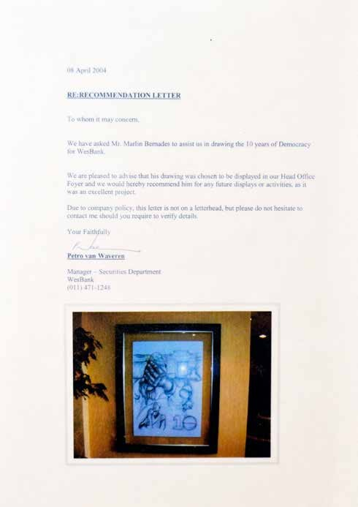
20 Sydney Road, Boksburg
Tel: 011 916-5330 • Fax: 011 918-6038
14/04/09
To whom it may concern
This is to certify that Marlon Bernardes served as an employee in the Production/Design Studio at the offices of Caxton East Rand from June 04, 2007 - October 31, 2008

Marlon was an outstanding Visualiser, Ad Designer and layout designer on 9 Newspaper publications and the Get It Magazine. His concepts were fresh and innovative, his diligence and dedication to his work was always evident.
Marlon is also an accomplished photographer, and he is still responsible for most of the Get It magazine photo and cover shoots.

Marlon demonstrated tremendous skill and dedication to any task that he undertook, he is an extremely fast learner, dealing with office procedure and the pressure of deadlines in his stride.
He is also a person who blends well with staff on a personal level and is always friendly and willing to help.

With his professional attitude towards his work, he will be an asset in any Design Studio or Office environment, I wish Marlon the best of luck in any avenue he pursues, I have no doubt that he will make a great success of it.
Amanda Thanasaras PRODUCTION MANAGER CAXTON EAST RAND
011 916-5331 • amandat@caxton.co.za
•Bedfordview/Edenvale News •Boksburg Advertiser
•JHB East Express •Germiston City News
•Benoni City Times •Kempton Express
•Brakpan Herald •The Tembisan
•Springs Advertiser
•The Outlook
•The African Reporter
•The Shopper
Magazines:
•Get It East Rand
•Get It Bedfordview/Edenvale

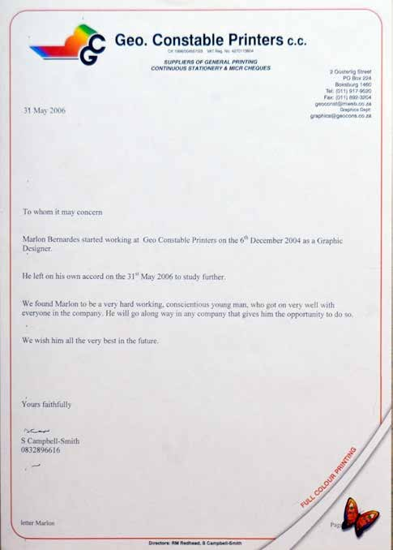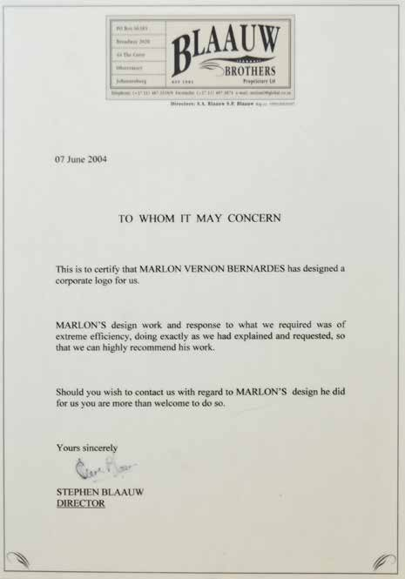

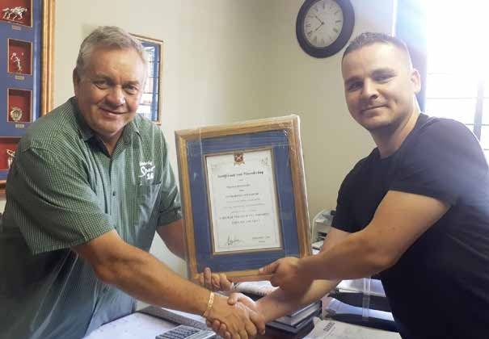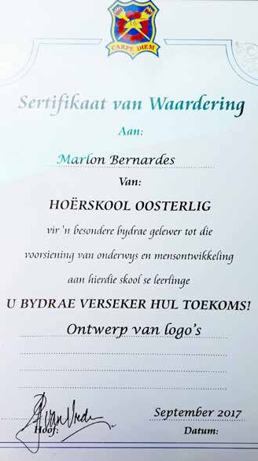

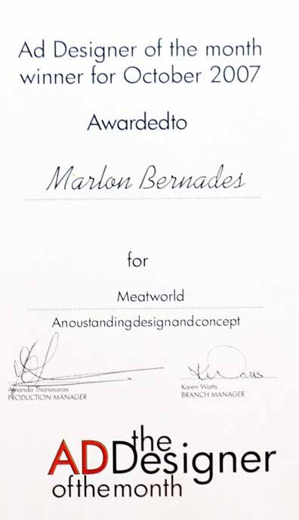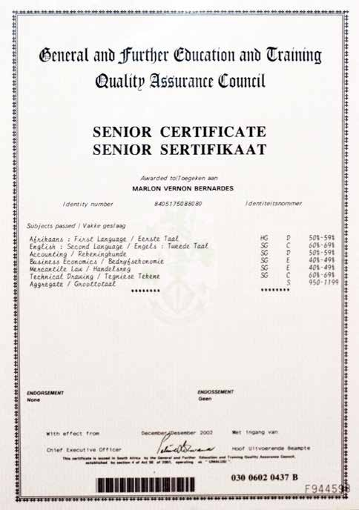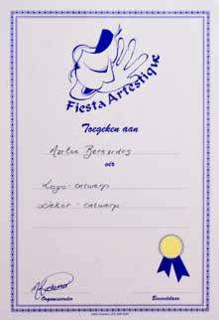

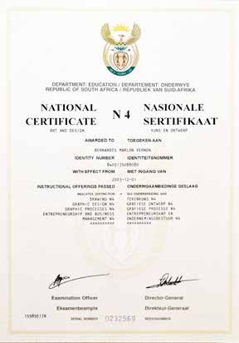
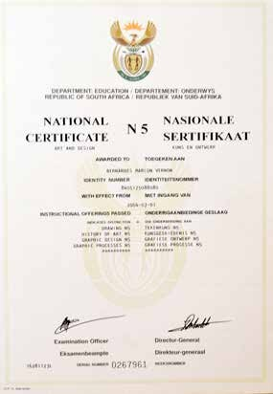

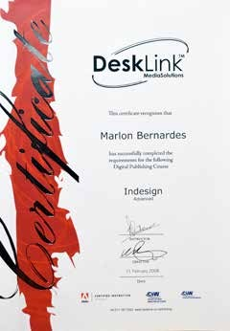

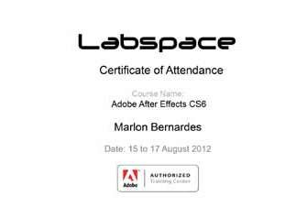


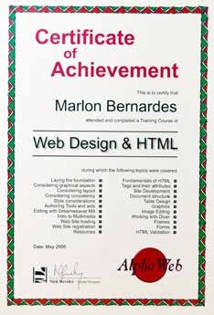

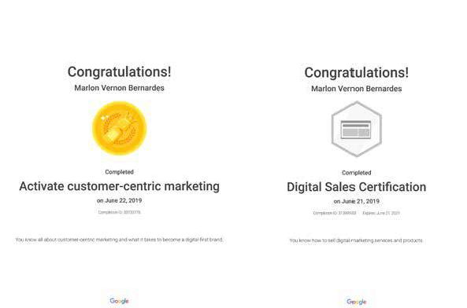
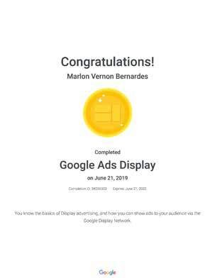
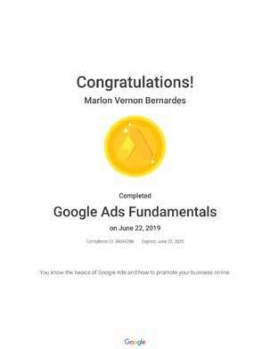
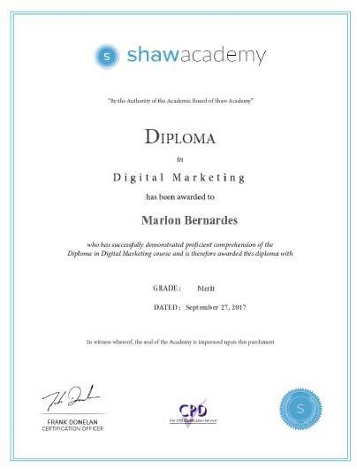
Certificates

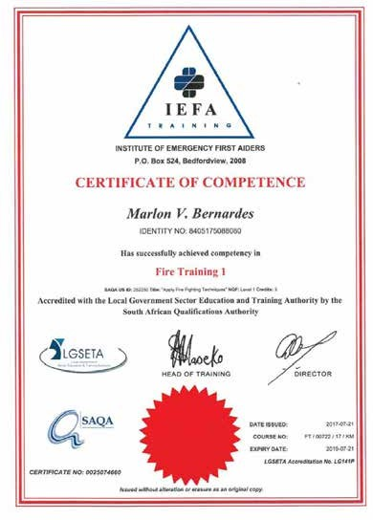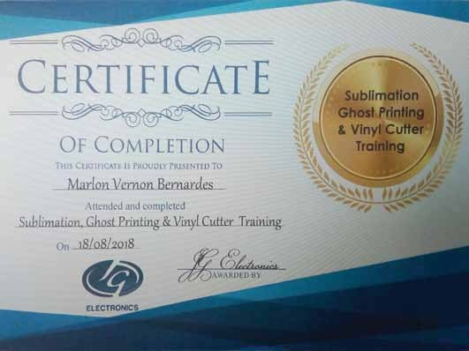

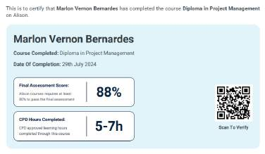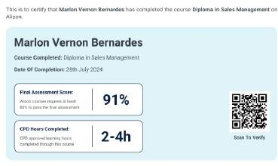
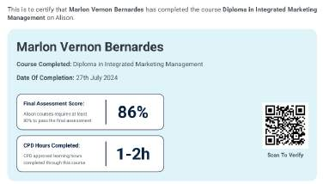
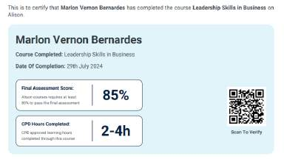

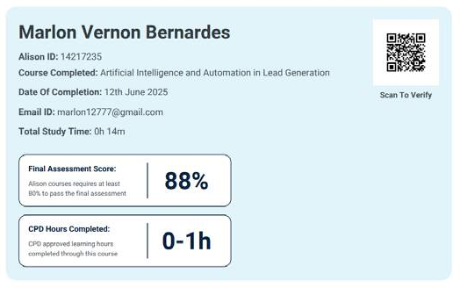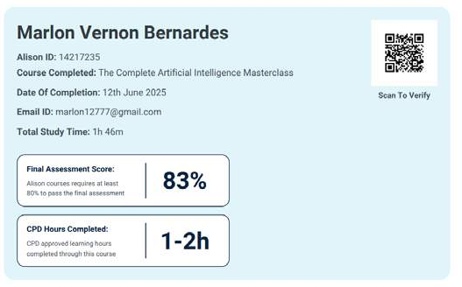
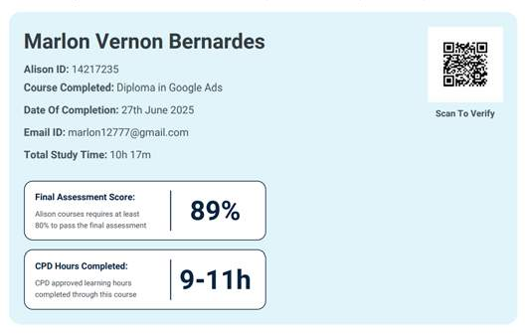
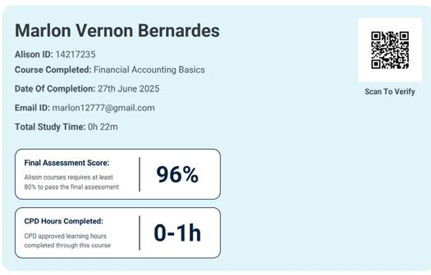

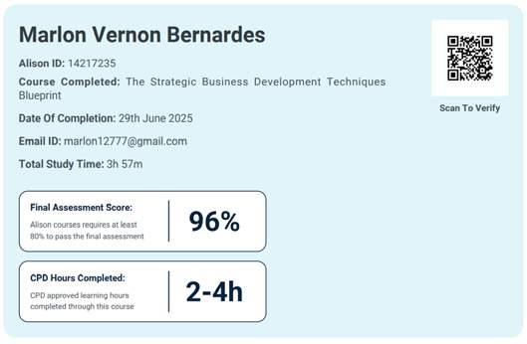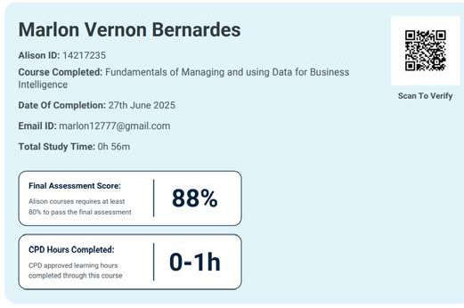
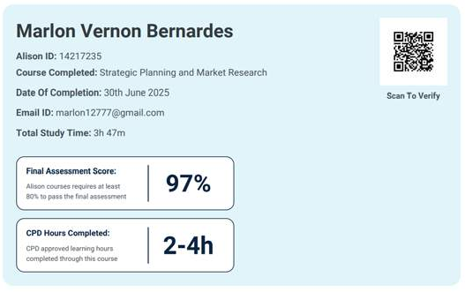

“I regard myself as a professional that works well with coworkers and management. I take pride in my work and ensure that it is high standard.” Always willing to learn when given the opportunity.”

Portfolio to view

MV

Marlon Vernon Bernardes

Address:
171 Lakeview Avenue, Muldersdrift (Hakunamatata Lodge & Health Spa)

Phone:
081 762 2831

E-mail:
marlon12777@gmail.com

